SEMINAR – BERT BREUKER

The Society of Homeopaths of the Federation of BIH is proud to present a three-day seminar on CEASE (Complete Elimination of Autistic Spectrum Expression) therapy developed by dr. Tinus Smits and presented by one his former students, a classical homeopath and a physical therapist, Bert Breuker. In this seminar we will be talking about vaccinations, post-vaccination syndrome, autism, successful treatment of autistic children, Inspiring homeopathy and discovery of universal layers that can be treated with specific remedies and much more.

Dates and place of the seminar: | 15, 16 and 17th of April 2011 – Sarajevo, Bosnia and Herzegovina, from 9.00 – 17.30
Price: | 110 Euro – registration until 31st of January  120 Euro – registration until 28th of February  130 Euro – registration until the 15th of April  (members of the Society have 10% discount on any price)
Topics: | CEASE therapy, post-vaccination syndrome, autism, isotherapy treatment, toxic substances, classical and inspiring homeopathy, live case, etc.
Certificates: | All attendees will receive a certificate of attendance with the number of hours and the topics listened.
Registration: | Please, all registrations send to lanamilavic@yahoo.com or to the phone number: + 38761 208 797 (Lana Milavic)
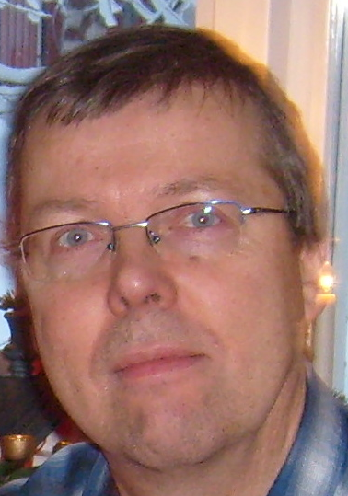
Bert Breuker says about himself:

I was born the 25th of November 1957 in Venlo, Holland.
I graduated in 1982 as a Physical Therapist.
I combined Homeopathy and Physical therapy immediately since I started studying homeopathy between 1982 and 1986 at the Dutch School of Homeopathy.

Between 1986 and 1991 I had my own practice and worked one day a week with Frans Vermeulen in his practice. During all these years, Frans has been my mentor and you could fairly say he became the biggest influence in how I work as a homeopath.
Between 1986 and 1992, I taught homeopathy at 4 different homeopathic schools in Holland of which the main was the Dutch School of Homeopathy which Frans Vermeulen run.
In 1991 I moved to Ireland and started the Irish School of Homeopathy together with 2 of my teachers from Holland.
I divided my time between my practice in Co. Clare in Ireland and teaching at the Irish School of Homeopathy and the Finnish School of Homeopathy in Helsinki.
I kept on working as a member of the examination board of the Dutch School of Homeopathy.
After a divorce, I moved away from Ireland in 1995 to start working as a teacher of homeopathy at the Homeopathic College in the north of Sweden. After a traveling period that won me the nick-name “the tubercular homeopath” I permanently settled in Sweden in 1997 continuing to work in my practice and teaching homeopathy.
After Frans Vermeulen also moved to Sweden in 2000 we started together the Swedish School of Homeopathy which we run till we closed it down in 2007.
I stopped working with homeopathy between 2008 and 2009 to refocus and do some soul searching.
In 2009 I did the Cease-education of Dr. Tinus Smits which I practice ever since and try to establish in Sweden.
My special experiences apart from those as a general homeopathic practitioner are:
- sterility, pregnancy, birth and early childhood since I started my homeopathic practice together with a midwife and worked alongside her.
- sports injuries because of combining my work as a PT with homeopathy.
- autism, ADHD and other related problems since I started with the Cease-method.
- damages from vaccines and other medication, poisons, chemicals, etc.

