Types of Cases for Considerations

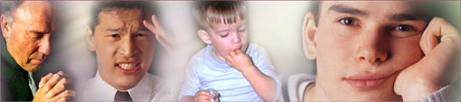

All subjects are presented through easy to grasp computerized PowerPoint slides and videos. Our experiences to be shared will cover topics on

Children Disorders :
Such as ADDH, Dyslexia, OCD, Autism, Cerebral palsy, Molluscum contagiosum, Dwarfism.
Pediatric malignancy - Acute myeloid leukemia, and Acute lympoid leukemia

Benign growths such as Gynaecomastia, Warts

Pathologically advanced cases
- Renal failure, Nephrotic syndrome
- Ovarian cyst, multiple fibroids
- Deafness, total hearing loss
- Progressive Muscular Dystrophy
- Cancer Lung, Nasopharyngeal Cancer, Cancer Caecum, Cancer Uterus, Cancer Kidney
- Hypertension and Cardiac Asthma
- Oesophageal Stricture

These cases are correlated, with Philosophy, Organon, Materia Medica, Repertory etc. to give complete totality of learning of Homoeopathy.

Body language



Body and behavioural signs with their correlation to the inner emotional state.

The body gives us indications that something is going wrong long before pathology develops. These indications can be read in the tone of the voice, the emotions, the complexion and even the body smell. The body and mind are a reflection of each other. The emotions and experience of life which form our personality also effect the formation and structure of muscle and tissue.

The lines, the cracks, the lopsidedness of each person are characteristics which say a great deal about the inner life and past experiences of that individual.

Our face is the mask we present to the world and therefore reveals a lot about our inner feelings.

Where there is a long standing inner conflict it follows into a chronic structuring on the face. This is an alarm, and if we as practitioners learn to read and understand this armoring we find a way into our patient’s feelings and problems.

Body language reflects the power, the fright, the anger or the sadness or past experiences.

This armoring can be seen not only on the face, but heard in the voice, seen in the emotional responses and even in the body smell! For example, deep vertical lines and dark shadows under the eyes are a sign of poor liver function which may show as problems with anger, planning and decision making.

The body language will be shared with the help of hundreds of slides, video cases, films and illustrations.

Behavioral and Psychiatric Disorders of Children

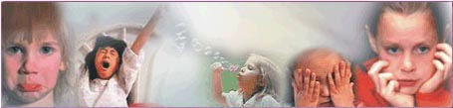

It is rightly said... “Each and every individual is a child at heart.”

The normal child is really healthy, is very much positive, vibrant and active. He is like a bud blossoming into a flower.

Normally the first five years are very important and are decisive for the rest of the life. Because of some unforeseen circumstances this child is not allowed to blossom in its formative years. This creates a mess in the later life.

An individual’s life can be broadly classified into Childhood, Adolescence, Adulthood and Old age. Each period of life has its own characteristic problems and disorders.

It is often seen that “childhood disorders claim greater importance because the majority of life patterns of the later ages have their direct or indirect bearing on those of childhood”.

One often surpasses the idea that children can be an easy target to behavioral disorders, and the signs and symptoms are left unnoticed. But now with the advent of behavioral sciences in the field of child psychology, it has become extremely easy to detect and treat such disorders as early as possible.

The art and science of Homoeopathy is a boon to mankind, where most of these disorders can be effectively dealt with. This involves detailed study of predisposition of children, hereditary as well as environmental impact on them.

With appropriate Homoeopathic treatment, the longevity and the quality of such children can be improved to a great extent. A proper case study and detailed evaluation allows the homoeopathic physician, to plan a proper course of action.

With the help of right Homoeopathic medicine one can literally channelise the energy to produce a better human being.

Let us create a healthy, harmonious, balanced world with the help of Homoeopathy.

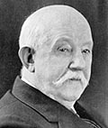

Referring Knerr’s Repertory

Knerrs repertory has symptoms, which are clinically verified. It has a treasure, which has remained totally unexplored. The most important aspects that are present in this repertory are :

1 | Different temperaments that are not covered in any other repertory
2 | Profession related disease like ‘Teacher’ or ‘Working in mines’ or one with ‘Sedentary habits’ and its related remedies
3 | Presence of detailed and exact descriptive rubrics, which can match with the symptoms expressed by the patient. As the rubrics are in the original words of the provers / patients, it presents finer expressions of the patient. Thus it helps us to find the Similimum faster.
4 | It has thousands of symptoms, which are unique, verified & can help in rapid cure of a case. e.g. In the rubric ‘Desire to go abroad’, only remedy is “Mercurius”.
5 | Different habits of an individual – Drunkard, high living, tobacco are enumerated.
6 | Complexion of an individual.
7 | Chapter of ‘Stages of life & Constitution provides lot of valuable data that is not present in other repertories.
8 | Many different chapters are present which are not found in any other repertory. For example, ‘Stages of Life and constitution; Location and Direction; Time, Temperature & Weather; Attacks, Periodicity; Rest, Position; Touch, Motion, Injuries; Pregnancy, Parturition, Lactation (Female Sexual Organs, Pregnancy and Parturition are present as separate chapters)

So if this repertory is not being used we are loosing out on lot of treasure, which means, treating many cases without giving Similimum.

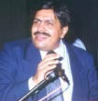

About Dr. Jawahar J. Shah M. D.

BELIEF …

The feeling of well being is the most beautiful gift that can be given to any person on this earth. This feeling is most gratifying when brought out in a Child, who is our tomorrow, and his well being leads to a healthy adult.

Right Medicine has excellent curative properties, healing from within, balancing all spiritual, emotional, intellectual, physical and pathological levels. HOMOEOPATHY provides the RIGHT MEDICINE.

Dr. Shah, a Homoeopath by training, is a Member of the Central Council of Homoeopathy, Ministry of Health & Family Welfare, Government of India.

Member of education committee which decides the education policy and manages 181 institutions and 31 Post graduation colleges. Dr. Shah lives and works in Mumbai, where he has been running a busy Homoeopathic practice for over 30 years.

He teaches at various schools in India and internationally as well as trains assistants. He has been the Director of Research at the Dr. Subodh Mehta Medical Centre, Mumbai since 1980 and is Director of the Child Guidance Clinic.

Winner of Dag Hammarskjold International Award for Alternative Medicine 1989, Switzerland
Invited guest speaker by the European Council of Classical Homeopathy (ECCH) at St. Gallen, Switzerland, May 2001
Exemplary Service award in Homoeopathy at the International Homoeopathy Conference (8 - 9 Feb, 2003)
Homoeopathic doctors of Maharashtra award for excellent and unmatched contribution to the Homoeopathic world , October 2003
Awarded for excellence in Homoeopathy by the
Director, Homoeopathy & Indian system of medicine
Deputy Director, Homoeopathy & Indian system of medicine
Registration Council of Homoeopathic system of medicine
President, Homoeopathic Medical Association of India
on occasion of 250 th birth anniversary of Hahnemann, founder of Homoeopathy
Govt. of Gujarat, India April 2005
Dr. Nigam’s award for excellence in Homoeopathic world awarded in April 2005
Awarded for unparallel contribution to Homoeopathy and Homoeopathic software development - Shri Rajarshi Chatrapati Shahu Memorial Homoeopathic conference, Kolhapur , June 2005

Dr. Shah has gained International recognition through his fascinating seminars and presentations around the world. The diversity and depth of his seminars offer both well founded theoretical background and extensive practical help for daily homoeopathic practice.

He has conducted more than 500 Seminars in 23 countries in 30 years. He is a contributor to various National and International Scientific Journals in the form of articles and research papers. In his seminars, he manages to capture his audience with his enthusiasm and humour. Many homoeopaths know Dr. Shah through his extensive publications and seminars.

In his last 30 years of association with Homoeopathy, Dr. Shah has played a major part in the development of the future of Homoeopathy in various capacities.

As one of the pioneers in Homoeopathic software development, Dr. Shah has been using IT to assist Homoeopaths in arriving at better cure by the software developed called Hompath. This software is India’s no.1 Homoeopathic software and one of the major software in 83 countries across the globe with a user base of about 25,000 Doctors.

Academician
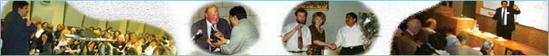

As an academician, Dr. Shah has been teaching Homoeopathy, both at the national and the International level. He has taught a large number of Homoeopaths in his lecture series. He has given more than 500 seminars in more than 22 countries all over the world.

No. of seminars internationally
Greece | 10 | Austria | 1
Australia | 7 | Srilanka | 2
U.K (London) | 7 | Israel | 2
Malaysia | 8 | Hungary (Budapest) | 2
Poland | 8 | Croatia | 3
Netherlands (Holland) | 2 | Slovakia | 1
U.S.A. | 2 | Bangladesh | 1
Canada | 2 | Kenya | 1
Germany | 3 | Qatar | 1
Bulgaria | 5 | Cyprus | 4
Switzerland | 1 | Bahrain | 1
Italy | 1 | Portugal | 1
South Africa | 1 | Pakistan | 2
Finland | 1

Practitioner


Dr. Shah has cured many patients purely with Classical Homoeopathic practice since last 30 years. He specializes in Bronchial Asthma, Behavioural and Psychiatric problems of children and Management of cancer patients.

Educationalist


Dr. Shah has been associated with the setting up of various Educational institutions in the country and abroad. As a member of the Educational Council, Central Council of Homoeopathy, Government of India, Dr. Shah has been dedicating special efforts in developing the Homoeopathic education in the country which handles 182 UG colleges and 31 colleges conducting Post Graduate (M.D) program in 7 subjects. He is also Associate Professor at the Pebble Hills University (PHU), School of Homoeopathic Medical Sciences.

Organiser
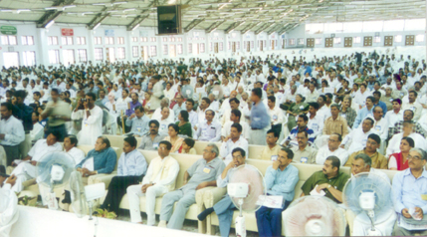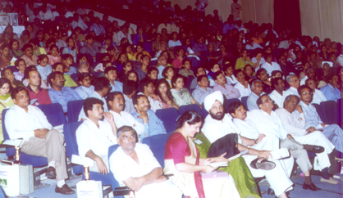
Organised conferences which had largest delegates in Asia. It had attendance of 2000, 2300 and 2800 in various conferences. Dr. Shah has been organizing Seminars for the Homoeopathic Fraternity. He has the credit of arranging seminars featuring Dr. George Vithoulkas, Dr. Alize Timmerman, Dr. Chaim Rosenthal, Dr. Prafull Vijaykar, Dr. Rajan Sankaran, Dr. Farokh Master, Dr. Kishore Mehta, Dr. Anil Bhatia, Dr. Parinaz Humranwala and other prominent doctors.

Technocrat


As one of the pioneers in Homoeopathic software development, Dr. Shah has been using IT to assist Homoeopaths in arriving at better cure by the software developed called Hompath. This software is India’s no.1 Homoeopathic software and one of the major software in 83 countries across the globe with a user base of about 25,000 Doctors. The software has practical experience which is not available in any other software.

Contact address

Dr. Jawahar J. Shah M.D.
8, New Hari Niwas, Dattatray Road
Santacruz (W), Mumbai (Bombay) - 400 054
Tel : +91 22 2661 4532 / 26616561
Email : hompath@vsnl.com jawaharjshah@yahoo.com
Web : www.hompath.com

* * * * * * * * * * * *

